***Project-Cause of Death***

***Introduction:-***

A straightforward way to assess the health status of a population is to focus on mortality – or concepts like child mortality or life expectancy, which are based on mortality estimates. A focus on mortality, however, does not take into account that the burden of diseases is not only that they kill people, but that they cause suffering to people who live with them. Assessing health outcomes by both mortality and morbidity (the prevalent diseases) provides a more encompassing view on health outcomes. This is the topic of this entry. The sum of mortality and morbidity is referred to as the ‘burden of disease’ and can be measured by a metric called ‘Disability Adjusted Life Years‘ (DALYs). DALYs are measuring lost health and are a standardized metric that allow for direct comparisons of disease burdens of different diseases across countries, between different populations, and over time. Conceptually, one DALY is the equivalent of losing one year in good health because of either premature death or disease or disability. One DALY represents one lost year of healthy life. The first ‘Global Burden of Disease’ (GBD) was GBD 1990 and the DALY metric was prominently featured in the World Bank’s 1993 World Development Report. Today it is published by both the researchers at the Institute of Health Metrics and Evaluation (IHME) and the ‘Disease Burden Unit’ at the World Health Organization (WHO), which was created in 1998. The IHME continues the work that was started in the early 1990s and publishes the Global Burden of Disease study.

***We have analysed the various types of death where surprisingly Acute hepatitis Deaths***

*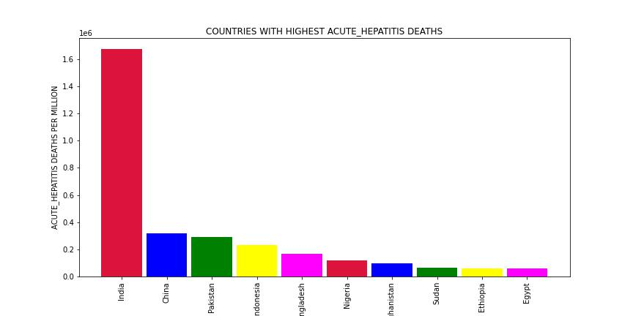  
The Disease Fatality*

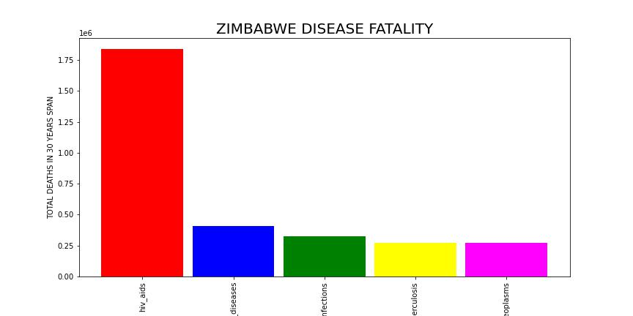

***Overall Highest***

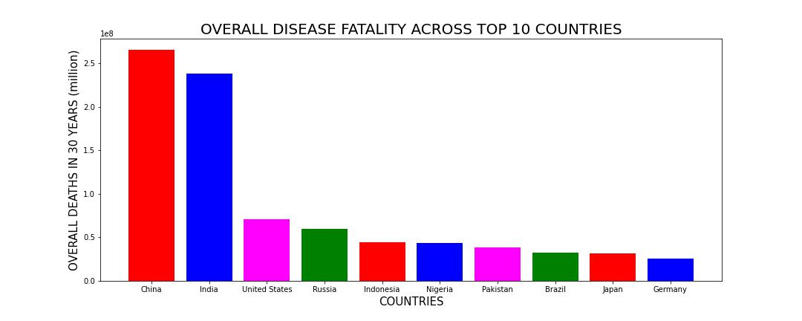

**In this Dataset, we have Historical Data of different cause of deaths for all ages around the World. The key features of this Dataset are: Meningitis, Alzheimer's Disease and Other Dementias, Parkinson's Disease, Nutritional Deficiencies, Malaria, Drowning, Interpersonal Violence, Maternal Disorders, HIV/AIDS, Drug Use Disorders, Tuberculosis, Cardiovascular Diseases, Lower Respiratory Infections, Neonatal Disorders, Alcohol Use Disorders, Self-harm, Exposure to Forces of Nature, Diarrheal Diseases, Environmental Heat and Cold Exposure, Neoplasms, Conflict and Terrorism, Diabetes Mellitus, Chronic Kidney Disease, Poisonings, Protein-Energy Malnutrition, Road Injuries, Chronic Respiratory Diseases, Cirrhosis and Other Chronic Liver Diseases, Digestive Diseases, Fire, Heat, and Hot Substances, Acute Hepatitis.**

***The Final Prediction***

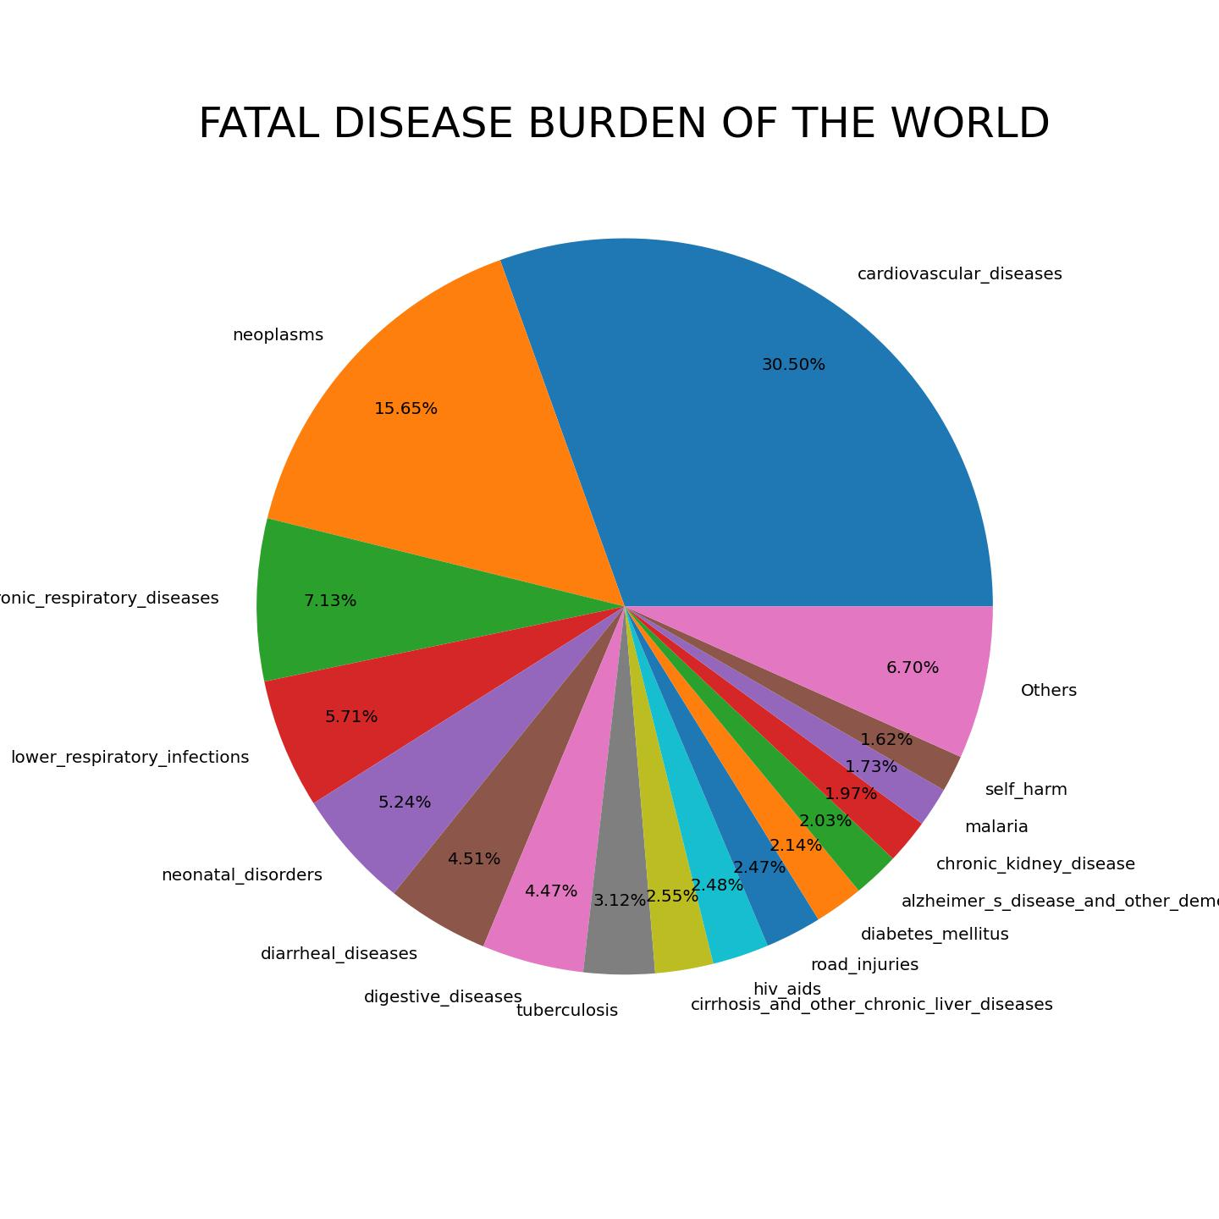

**OBSERVATIONS CHINA , INDIA AND USA face the largest brunt of deaths due to diseases in the world Cardiovascular diseases , Neoplasms (Malignancy/Cancer) and Lower Respiratory Tract Infections (for example : Pneumonia) are the top 3 killer disases in the world.**